Façade Improvement Program
A Collaborative Grant Program between Auburn Main Street, the City of Auburn, and the Auburn Redevelopment Commission
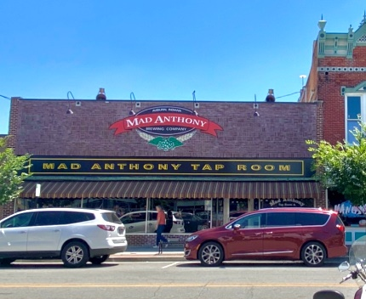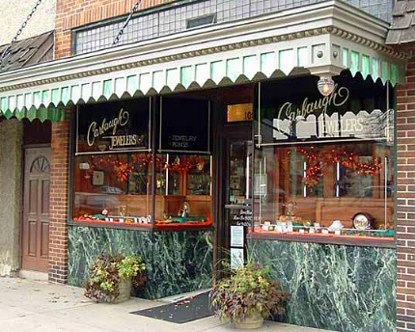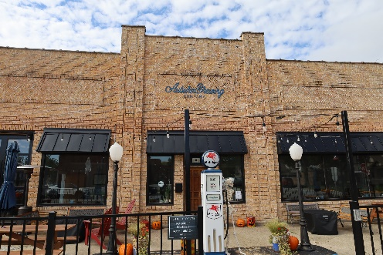
Overview ______________________________________________________________
This is a Façade Grant Program in conjunction with the City’s Building, Planning and Development Department, Auburn Main Street (AMS), and the Auburn Redevelopment Commission. This program is designed to encourage both downtown business and/or building owners to improve the aesthetic appearance of their historical building façade to help stimulate commerce and enhance the overall business environment of the downtown’s historic corridor.
The “Facade Improvement Program” is a fifty percent (50%) matching grant, with a maximum grant amount of $15,000 and projects can be requested in phases.
The Program focuses on the improvement of existing buildings. Eligible expenses include exterior building improvements, exterior lighting, new and/or renovated signs, awnings, historic façade elements, windows and doors, and similar projects. A 100% reimbursement of actual architectural or engineering costs associated with façade improvements, providing the owner utilizes the technical input in the façade renovation, not to exceed $2,500.
In addition to code and ordinance compliance, any facade improvement project shall be required to comply with specific design guidelines intended to retain and/or enhance the character and historical value of the Downtown Business District. Buildings eligible for the Façade Improvement Grant shall be at least 50 years old, in the designated improvement area, and used for commercial or business purposes. Buildings or structures owned by governmental units nor those owned by organizations primarily supported by property tax revenues are not eligible for Façade Grant funds.
__________________________________________________________________________________
To Schedule a pre-application meeting contact:
For more information about Downtown Auburn’s Facade Improvement Program, please contact the AMS Facade Review and Design Committee Chair, Logan Shank @ (260)515-3967 logan.shank01@gmail.com or City of Auburn, Building, and Planning Administrator at 925-6449

Façade Improvement Program
Instructions and Guidelines
Façade Improvement Program; Collaborative Grant Program between Auburn Main Street, the City of Auburn, and the Auburn Redevelopment Commission
Instructions for Applying
_______________________________________________________________________
Step 1. Pre-application meeting: Schedule a pre-application meeting with representatives from Auburn Main Street (AMS) and/or the City of Auburn Department of Building, Planning; and Development for an initial discussion (however they will direct you to the AMS Representative for the initial meeting).
Please contact:
AMS Facade Review and Design Committee Chair, Logan Shank (260) 515-3967 logan.shank01@gmail.com or the City of Auburn Building, Planning, and Development Administrator, at 925-6449

Step 2. Program Review: Review and become familiar with the Program Goals and Objectives and Design Guidelines. Determine if the project supports the Program Goals and Objectives and can comply with the Design Guidelines.

Step 3. Application: Complete Application and submit the following:
- Completed Application.
- Detailed scope of work, including all work that is part of the façade grant project.
- Complete exterior materials list.
- Two written cost estimates for the project, including the cost of materials.
- Current photographs of the property showing the facade of the building to be improved or the areas of the site to be improved. Include notations on the photographs (or on separate drawings) illustrating the areas or features of the building/site that will be improved.
- Written authorization to proceed, signed by the property owner (if different from the applicant).
- For sign projects, include a color rendering of the proposed sign with dimensions. Indicate where and how the sign will be installed on the building by illustrating it on photograph of the building.
- For painting projects, provide swatches of the preferred color scheme and indicate on a photo of the building which colors will be used and where on the building.
- For awning projects, provide swatches of the preferred fabric and color scheme and indicate on a photo of the building where the awning will be installed.

4. Review: AMS’s Façade Grant Review Committee will review all applications. Depending on the scope of work, the Committee may request a site visit and/or additional meetings with the applicant. The Façade Grant Review Committee will rate each application based on several factors including building location, extent of rehabilitation work, impact of the project to the downtown area, additional investment, current and proposed uses, and historic rating.

5. Final Determination: AMS’s Façade Grant Review Committee will make a final determination on the grant request and communicate that decision in a final determination letter/email to the applicant. If the grant is approved, the final determination letter/email will include a Notice to Proceed (see next step). If the grant is denied, the final determination letter/email will include justification for the denial.

6. Notice to Proceed: A Notice to Proceed will be issued detailing amount of grant funding awarded and a schedule for completion usually within 6 months. Only approved work will be eligible for the grant. No work shall commence prior to receiving a Notice to Proceed!

7. Permits, Construction, and Timeframe: The applicant is responsible for obtaining all necessary local and/or state permits required to perform the work. If changes are necessary once construction begins, such changes must be submitted to the Design Review Committee for approval PRIOR to continuing the work.

Unapproved changes may void your grant funding. All facade improvements must be completed within six months of the Notice to Proceed. One six-month extension may be granted on a case-by-case basis. If work has not been completed by the end of the extension period, the applicant shall re-apply for funding.
8. Grant Funds: Disbursement of grant funds will be made as a reimbursement to the Applicant upon verification that the match has been paid and that work has been completed according to the:

A) application.
B) adherence to the Secretary of the Interior’s Standards for Rehabilitation Guidelines and;
C) recommendations, if any, from the Façade Grant Review Committee. Copies of paid invoices and proof of match payment such as a cancelled check is required. Payment will be issued upon verification of work and local match payment; usually within 2 weeks.

Façade Improvement Matching Grant

GRANT GUIDELINES
This program is funded from a combination of all sources permitted by Indiana statute. These sources currently include the captured allocations from the Tax Increment Financing (TIF) District, donations, and grants.
The program offers an opportunity for a property owner or tenant to receive monetary grant assistance for improvements to their property. All grants awarded (apart from the Architectural and Engineering Assistance Grant) require a matching dollar-for-dollar expenditure by the owner, tenant, or other reliable funding source (such as a bank loan or additional grant funds).
Grants will be awarded based upon a needs assessment by the Auburn Main Street Façade Review Committee, and such applications must be submitted in their entirety - with all the necessary supporting documents attached - before they will be considered for review by the Auburn Main Street Façade Grant Review Committee.
Grant awards may not exceed $15,000, for individual projects this can include up to $2,500 for architectural or engineering assistance, to be awarded as follows:
- Façade improvement: Up to a 50% maximum reimbursement of actual costs for eligible activities.
- Awnings: Up to a 50% maximum reimbursement of actual costs associated with additional improvements or replacement awnings.
- Signage / Lighting / Murals: Up to a 50% maximum reimbursement of actual costs associated with addition, improvement or replacement of signs, lighting, or murals.
- Architectural or Engineering Assistance: A 100% reimbursement of actual architectural or engineering costs associated with façade improvements, providing the owner utilizes the technical input in the façade renovation, not to exceed $2,500. A licensed architect or engineer shall be retained for concept drawings, specifications, and consultation to maintain the historical character of any building renovation.

ELIGIBILITY REQUIREMENTS
- The properties building must be in the defined Façade Improvement Program area, and either be a contributing historical building or 50 years or older. The program area is defined as all qualifying properties in the Economic Development Area. See attached “Exhibit A” for a map.
- The applicant(s) must be the building owner. Tenants may qualify upon receiving written consent from the building owner. Buildings eligible for the Façade Improvement Grant shall be at least 50 years old, in the designated improvement area, and used for commercial or business purposes.
- Buildings or structures owned by governmental units nor those owned by organizations primarily supported by property tax revenues are not eligible for Façade Grant funds.

ELIGIBLE ACTIVITIES
- Accentuating the existing features of the building through painting, lighting restoration, replacement, cleaning, or other treatment of exterior surfaces.
- The addition of design elements which may have appeared on the original building, or are in keeping with the building's character, e.g., awnings.
- Repair to building exterior facades (front, rear, and side facades are eligible and encouraged).
- Masonry and major structural repairs to any “street facing exterior walls” (major structural repairs require appropriate plans prepared by a qualified structural engineer whose fees are eligible to be included within the matching grant application).
- Building envelope components relating to controlling the flow of air and water. This includes such items as glazing, curtain walls, tuck pointing, parapet walls, flashing, caulking, sealants, membranes, moisture barriers, and condensation control.
- Cleaning of building exterior.
- Exterior painting.
- Repairing or replacing cornices, entrances, doors, windows, decorative detail, and/or awnings.
NOTE: All exterior colors chosen will be reflective and selected from a historical color pallet and representative of our current downtown color pallet.
- Sign removal, repair, or replacement.
- Other repairs that may improve the aesthetic quality of the building.
- Façade renovation - must involve the general upgrading of a building's external appearance.

INELIGIBLE ACTIVITIES
- Interior improvements (except window display areas).
- Asbestos, mold, and mildew removal and/or mitigation.
- Sidewalks.
- Purchase of furnishings, equipment, or other personal property not part of the real estate.
- Improvements completed, or in progress, prior to notification of approval.
- Repair or creation of features not compatible with original architecture. (NOTE: These items may be eligible if required by government rules and/or regulations such as ADA ramps and such).
- Façade grants are not meant to replace your insurance deductible.
- Projects that cover up historical architectural features of the building’s façade.
- Improvements to roofing systems or roof structures.
- Buildings or structures owned by governmental units nor those owned by organizations primarily supported by property tax revenues are not eligible for Façade Grant funds.

GRANT PROCESS
1. Submittal shall include:
a. One estimate is to be provided for proposed improvements by qualified contractors.
b. Written description of proposed improvements, including materials and color.
c. Supporting data if applicable (photos are helpful).
d. Completed application.

2. Auburn Main Street Facade Review:
  - Repeat applications for the same property will be accepted as funds and improvement needs allow. Priority will be given to those who have not applied for funds in the previous year.
  - The Auburn Main Street Façade Review Committee will review all applications submitted prior to their regularly scheduled monthly meeting, as long as program funds are available.
  - Grants will be awarded based on available funding and the merits of the proposed improvements.
  - The Auburn Main Street Façade Review Committee will make every reasonable attempt to use sound judgment and principles in arriving at an equitable distribution of the available funds.
    - Encouraging coordination of effort among adjoining properties.
    - Responding to needs (safety, aesthetic, structural, energy saving, etc.).
    - Balancing distribution of funds (although non-for-profit owners qualify for this program, their applications and needs will be evaluated with an attempt to achieve an equitable balance of funding with those properties contributing to the TIF funds).

- Façade Review Final Approval:
  - The Auburn Main Street Façade Review Committee will review application(s), determine if the project qualifies for assistance, and determine the amount of the grant. Awards may not exceed 50% of the lowest estimate (quote). Applicant may select a contractor with a higher quote and pay the difference.
  - The Auburn Main Street Façade Review Committee will issue a written authorization to proceed to each successful applicant.
  - Work for which a grant is sought shall not begin before receiving the written authorization to proceed/approval from the Auburn Main Street Façade Review Committee.
  - Grantee is responsible for obtaining any permits required to do the project. If scaffolding is required within the right of way, Board of Works approval may be needed.
  - Once approval is granted, any changes to the original submission must be resubmitted and reviewed by the Auburn Main Street Façade Review Committee.

- Disbursement for grant payments will be made as follows:
  - 100% of total grant award payable upon final inspection and verification that the work has been completed according to the application and final approval. Verification of completion of work will be required either by the Auburn Building Inspector, if work required a building permit, or by the owner, if work is completed to their satisfaction. A Claim Form will be submitted requesting funding be paid by the Auburn Main Street Façade Review Committee to the Auburn Redevelopment Commission for approval. No monies will be paid out to recipients up front.
  - All improvements must be completed within six months unless an extension is granted by the Auburn Main Street Façade Review Committee following a written request from the applicant.
  - After receiving verification that the work has been completed satisfactorily and that the applicant's portion of the contract has been paid, along with copies of final invoices, the Façade Review Committee will take pictures and verify the work has been completed.
  - The Façade Review Committee will submit to the Auburn Redevelopment Commission a Claim Form for payment and upon receipt of funds will pay the grant portion of the project directly to the applicant for reimbursement.
Questions _______________________________________________________________________
For more information about Downtown Auburn’s Facade Improvement Program, please contact the AMS Facade Review and Design Committee Chair, Logan Shank @ (260)515-3967 logan.shank01@gmail.com or City of Auburn, Building, and Planning Administrator at 925-6449.
Façade Improvement Program Application
A collaborative grant program between Auburn Main Street, Auburn Redevelopment Commission, and the City of Auburn.
Applicant Building Owner Information
Applicant(s) Name: _____________________________________________________________________________
Mailing Address: _______________________________________________________________________________
Business Name: _______________________________________________________________________________
Business Type: Retail Service Professional Non-profit Other
Project Address: _____________________________________________________________________________
Phone Numbers: ____________________________________________________________________________
Email: _______________________________________________________________________________________
Project Scope of Work Information
Provide a brief description of the project, including key elements. Attach additional information as required by the Instructions.
Windows: Removal______ New______ Altered_____ Repaired______
Painting (Approximate Sq Ft Area): _____________________________
Masonry Repairs: _______________________________________________
Other (Please Specify): ________________________________________________________________________
Estimated Project Cost: ________________________________________
Grant Funds Requested: _______________________________________
Anticipated Start/Completion Dates: _____________________ / ___________________________
This is a 50% matching grant program. Engineering and architectural planning assistance is 100% reimbursable up to $2,500. The level of funding will be determined by the Façade Grant Committee. Projects are funded based on availability at the time in which the application is received. By signing below, applicant acknowledges all terms and conditions associated with this grant program and agrees to comply with all requirements.
I hereby submit the attached plans, specification(s), and color samples for the proposed project, and understand that these must be approved by the Auburn Main Street Façade Grant Committee. I understand that no work shall begin until the grant has been fully approved and I further understand that my project must be completed within 6 months or within a timeframe that is deemed reasonable by the Committee. The full grant sum will be paid when the project is complete. I also agree to leave the complete project in its approved design and colors for a period of five (5) years form the date of completion unless additional improvements are deemed necessary.
__________________________________________________ ________________________________
Applicant (Building Owner) Date
__________________________________________________ ________________________________
Applicant (Building Owner) Date

